2026
Alhathal Naif Mashaan D
SW01084553
Course: CISB5123
Instructor: Nur Laila Ab Ghani
Submission Date: 14-March-2026

[Sentiment Analysis Using Lexicon-Based and Machine Learning Approaches]

Introduction

Sentiment Analysis is a method of the natural language processing (NLP) to realize whether a piece of writing has a positive or negative emotional tint. It is the most common approach used in categorizing text in terms of positive, negative or neutral. Sentiment analysis helps organizations and researchers to understand customer behavior, review product comments, and feedback in social media.
Sentiment analysis is done through a number of methods. These approaches can be broadly classified into two key categories namely, lexicon-based and machine learning-based approaches. Methods based on lexicon work with a pre-existing set of dictionaries of words and sentiment scores, whereas machine learning approaches use algorithms to identify patterns of the text and automatically identify sentiments.
The two methods are applied in this assignment and compared with Python. TextBlob and VADER are used to undertake the lexicon-based analysis, whereas Naive Bayes and Support Vector Machine (SVM) classifiers are used with the machine learning analysis.

Objective

The key purposes of this assignment are:
- To apply sentiment analysis by applying a lexicon-based method.
- To apply sentiment analysis with the help of a machine learning approach.
- To determine the performance of the various sentiment classification techniques.
- To measure the performance by classification reports of precision, recall, and the F1-score.

Methodology
3.1 Dataset

The experiment made a dataset of 30 sentences of product reviews. The labels of the real sentiment categories of every sentence were used manually namely; positive, negative and neutral.
Examples of data set entries are:
- It is a wonderful product and I love it! (Positive)
- This product is abhorrent, I dislike it. (Negative)
- Okay it is not bad but it is also not great. (Neutral)

High and low sentiment analysis The sentiment analysis methods were tested on these sample texts.

3.2 Lexicon-Based Approach

The lexicon-based model defines sentiment using words which have sentiment values as predefined dictionaries.
This approach employed two of the most common tools:

TextBlob
TextBlob is a program written in Python used to perform the processing of textual information. It evaluates the score of polarities between -1 and +1:
- Values within the range 3 to 6 - Positive sentiment.
- Value - Negative sentiment = -1.
- Zero - Neutral sentiment
The score of polarity is then transformed to sentiment labels.

VADER
Or another lexicon-based sentiment analyzer that is also expressly tailored to social media text is VADER (Valence Aware Dictionary and Sentiment Reasoner).
VADER derives a compound score of -1 to +1. The sentiment threshold is calculated in the following ways:
- Compound > 0.05 - Positive
- Compound < -0.05 - Negative
- Between -0.05 and 0.05 - Neutral
The program works on every sentence and retrieves the results on a table with the sentiment forecasts.

3.3 Approach based on machine learning.

Machine learning algorithms detect trends on data to automatically categorize the sentiments.
It was done by the following steps:
Data Splitting

The traintestsplit function was used to split the data into training and testing data, the train data was 60, and the test data was 40.

Feature Extraction
Machine learning algorithms cannot make use of text data directly. As such, CountVectorizer was employed to change text to a Bag-of-Words representation which changes text to numerical feature vectors.

Classifiers

There were two trained classifiers:
Naive Bayes
Naive Bayes is a probabilistic machine learning algorithm which is more often used to classify text. It presupposes that words are independent and determines the probability of each sentiment category.

Support Vector Machine (SVM)
SVM is a supervised learning algorithm which identifies the most ideal boundary to distinguish various classes of data. This assignment employed a linear kernel SVM in grading sentiments.
Both of the models had been trained on the training data and subsequently applied to test the sentiments of the testing data.
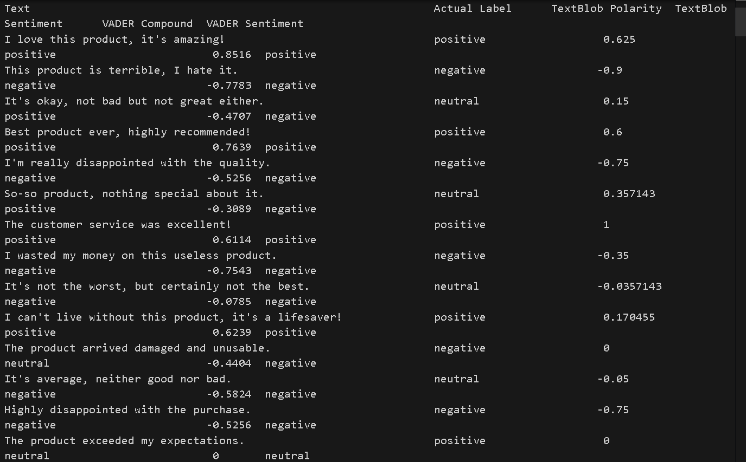

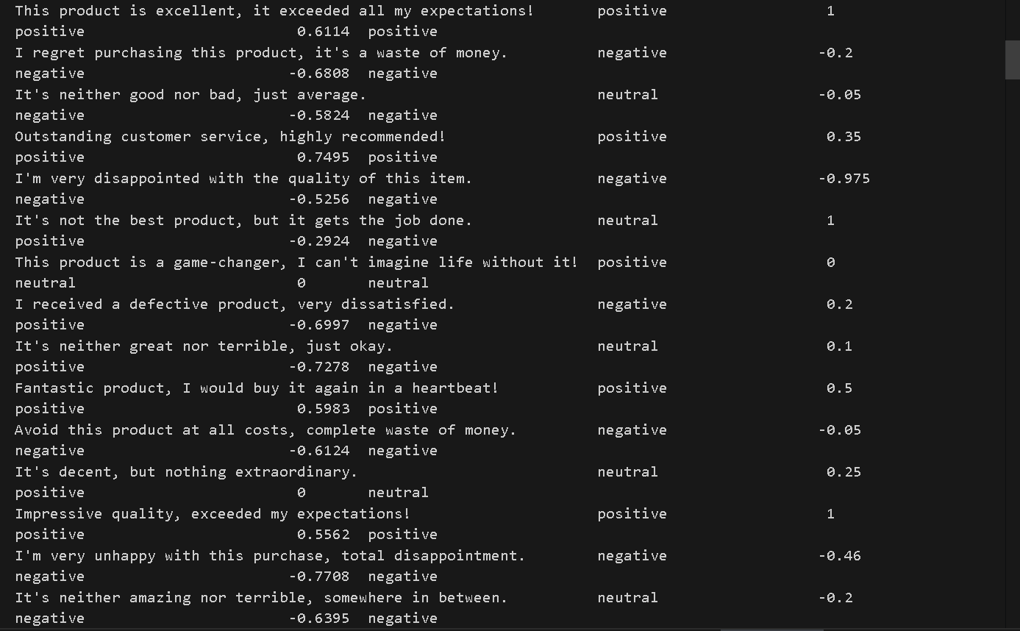

Results and Output

A number of outputs were generated by the program such as sentiment prediction tables and classification reports.

4.1 Lexicon-Based Results
TextBlob was adopted to analyze the sentiment of each sample of text using VADER. The results included:
- Actual sentiment label
- TextBlob sentiment and predicted sentiment.
- Predicted sentiment and VADER compound score.
The result was presented in the form of a table with the tabulate library.

4.2 Classification Reports
Reports on classification were produced to compare the performance of every model
.
These reports include:
- Precision Precision of positive predictions.
- Recall: Capacity to locate all the pertinent cases.
- F1-score: Precision and recall trade off.
- Accuracy: General accuracy of predictions.

Individual reports on the following were created:
- TextBlob

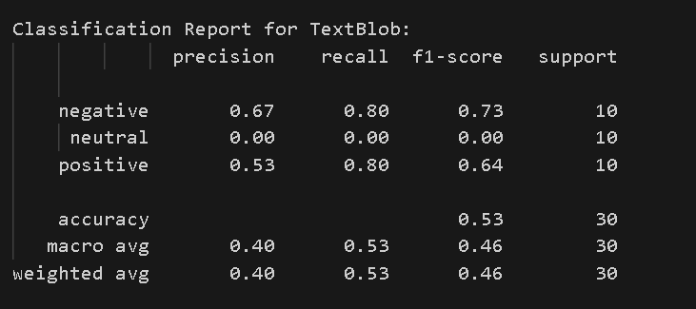
- VADER
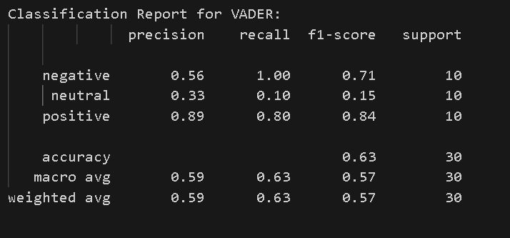
- Naive Bayes
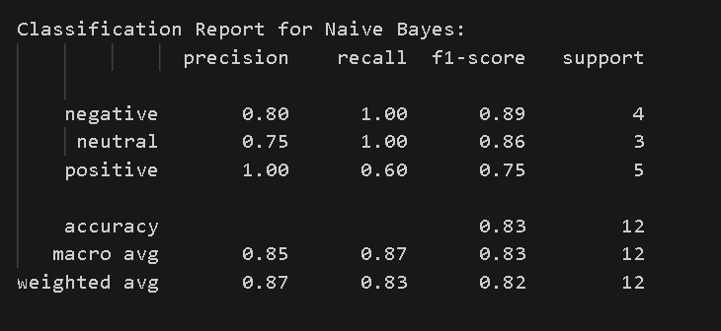
- Support Vector Machine
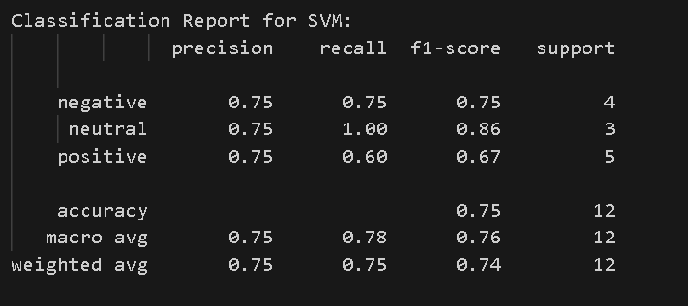

Interpretation of Results

According to the classification reports, we have risen the following observations:

TextBlob
TextBlob had a moderately good performance with both the positive and negative sentiments but low performance with the neutral sentiment in classification.

VADER
VADER performed well in identifying positive and negative emotions because of its optimality in terms of sentiment dictionary.

Naive Bayes
Naive Bayes classifier was able to record better accuracy and balanced results with all the sentiment types. It was efficient in that it learnt patterns based on the data.

Support Vector Machine (SVM)
SVM too generated good results of classification and good precision and recall values. Its performance in this dataset was not that good as compared to Naive Bayes but it was still reliable.
All in all, the methods based on machine learning worked better than the ones based on lexicon on this dataset.

Conclusion
This assignment revealed the application of sentiment analysis based on both lexicon and machine learning techniques.
The lexicon-driven approaches (TextBlob and VADER) gave the fast sentiment forecasting mechanisms with respect to preset thesauruses. Their performances were however; low when it came to neutral or ambigent sentences.
Patterns that were learned directly through the training data gave the machine learning methods (Naive Bayes and SVM) a greater overall accuracy.
Finally, although the lexicon-based techniques are easy and straightforward to adopt, the machine learning models are usually more precise in their sentiment classification, in case they are trained with adequate data.

